how to Use AI in the Quality field

AI Documentation Plan

Prepared by: Email: ￼

Eslam Lotfy Abd Elaal

*The purpose of this AI Documentation Plan is to provide you with the support and guidance needed to succeed in applying AI in the software Field.*

Our Agenda

|  |  |
| --- | --- |
| Topic 1 | * Generate code and explain code Automation scripts using Katalon Studio Assist. |
| Topic 2 | * Shifting Left with GPT Manual Test Generator for Jira. * Generate Test cases. * Increases Test Coverage. * Test optimization. |
| Topic 3 | * Visual Testing by Katalon studio by Applitools. |
| Topic 4 | * Visual Testing by Katalon studio |
| * Topic 5 | * *ChatGPT* |

* Generate code and explain code Automation scrips using Katalon Studio Assist.

**Steps to be followed:**

* Open the katalon studio platform.
* Click on the studio assist icon.
* Add API Key through: <https://platform.openai.com/account/organization>
* Click save.
* Go to script mode and add the below code.
  + /* Write me a test case that:
  + * 1. Open a browser to a URL
  + * 2. Log in to the website
  + * 3. Click the login button
  + * 4. Input username and password
  + * 5. Close the browser
  + */
* Right-click and select Generate code.
* Check Code generated is displayed successfully.
* Right-click and select Explain code.
* Check explaining codes are displayed successfully.

* Shifting Left with GPT Manual Test Generator for Jira.
* Generate Test cases.
* Increases Test Coverage.
* Test optimization.

**Steps to be followed:**

* Create an account on Jira Cloud.
* Enable Jira integration through <https://testops.katalon.io/team/988072/project/1001301/integrations?type=jira_integration>
* Add URL - Username – Password through <https://id.atlassian.com/manage-profile/security/api-tokens>.
* Click Test connection.
* Go to and install plugin through <https://marketplace.atlassian.com/apps/1217501/katalon-bdd-test-automation-for-jira?hosting=cloud&tab=overview>
* Go to the Jira cloud website.
* Create Project > Epic > Task.
* Check **katalon Manual Tests** plugin is displayed.
* Click on **Generate manual test cases.**
* Click on **save to katalon**.
* Check test cases are now linked in the **Linked Test Cases** section**.**

* Visual Testing Katalon studio by Applitools.

**Steps to be followed:**

* Open Katalon studio platform.
* Go manage plugin and install plugin through <https://store.katalon.com/product/44/Applitools-Integration>.
* Install **Applitools Integration** plugin.
* Go to katalon studio and open script mode.
* Add your “own code” on the katalon platform (check Window).
* Run the code and check the result before deployment on <https://eyes.applitools.com/app/test-results>
* Run the code and check the result after deployment on <https://eyes.applitools.com/app/test-results>
* Compare the **baseline image** before deployment against the **new image** after deployment.

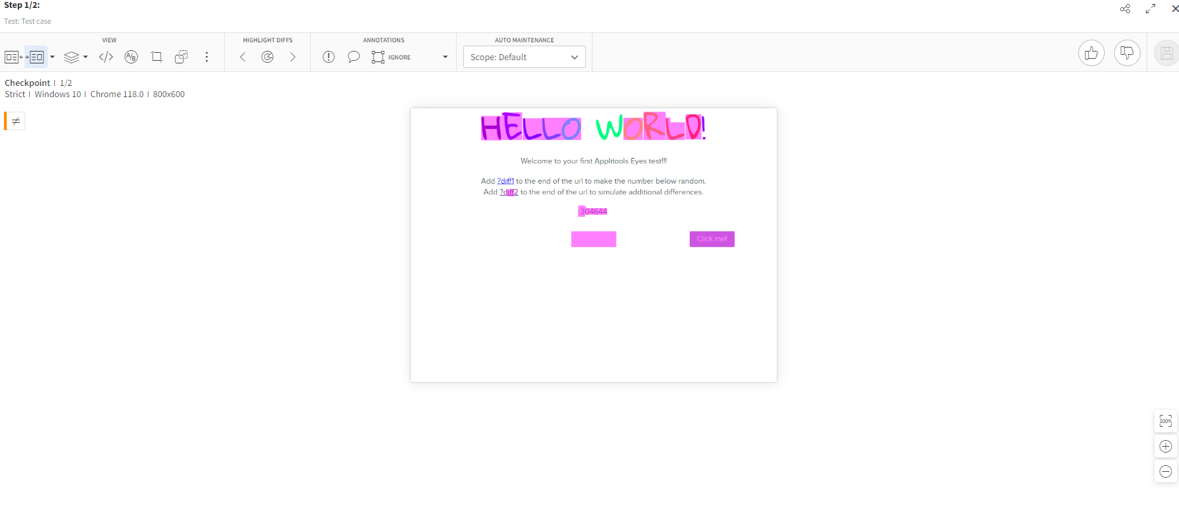

**Steps to be followed:**

* Visual Testing by Katalon studio.
* Open Katalon studio platform.
* Check integration enabled Katalon Studio Integration
* Go testOps Go to Visual Testing > Visual Test Runs
* Open https://testops.katalon.io
* Click on id there is baseline image and is passed by default
* Test Suite has passed, the screenshots are automatically marked as Passed
* Click on the **Baseline Collection ID** you want to check.
* run the Test Suite again and the Visual Test Run is then marked as **Unresolved**
* Check the baseline image to compare the checkpoint.

